**ASSIGNMENT-1**

Build a smart home in Thinkercad with 2 sensors, an Led, buzzer and submit it.

|  |  |
| --- | --- |
| Assignment Date | October 2022 |
| Student name | Durkesh D |
| Student Roll no | 19EC023(MECR19EC023) |
| Maximum Marks | 2 marks |

**Question 1**

Build a smart home in Thinkercad with 2 sensors, an Led, buzzer and submit it.

**CODE:**

int t=2;

int e=3;

void setup()

{

Serial.begin(9600);

pinMode(t,OUTPUT);

pinMode(e,INPUT);

pinMode(12,OUTPUT);

}

void loop()

{

//ultrasonic sensor Code

digitalWrite(t,LOW);

digitalWrite(t,HIGH);

delayMicroseconds(10);

digitalWrite(t,LOW);

float dur=pulseIn(e,HIGH);

int dis = dur * 0.034 / 2;

Serial.print("Distance is: ");

Serial.print(dis);

//LED ON Code

if(dis<=10)

{

digitalWrite(8,HIGH);

}

else{

digitalWrite(7,HIGH);

}

//Buzzer For ultrasonic Sensor Code

if(dis<=30)

{

for(int i=0; i<=40; i=i+10)

{

tone(12,i);

delay(1000);

noTone(12);

delay(1000);

}

}

//Temperate Sensor Code

double a= analogRead(A0);

double tem=(((a/1024)*5)-0.5)*100;

Serial.print("Temp Value: ");

Serial.println(tem);

delay(1000);

//LED ON Code

if(t>=38)

{

digitalWrite(8,HIGH);

}

else

{

digitalWrite(7,HIGH);

}

//Buzzer for Temperature Sensor Code

if(tem>=38)

{

digitalWrite(7,LOW);

digitalWrite(8,HIGH);

for(int i=0; i<=30; i=i+10)

{

tone(12,i);

delay(1000);

noTone(12);

delay(1000);

}

}

//LED OFF Code

if(t<38)

{

digitalWrite(8,LOW);

digitalWrite(7,HIGH);

}

else

{

digitalWrite(8,HIGH);

digitalWrite(7,LOW);

}

}

**CIRCUIT DIAGRAM WITH OUTPUT:**

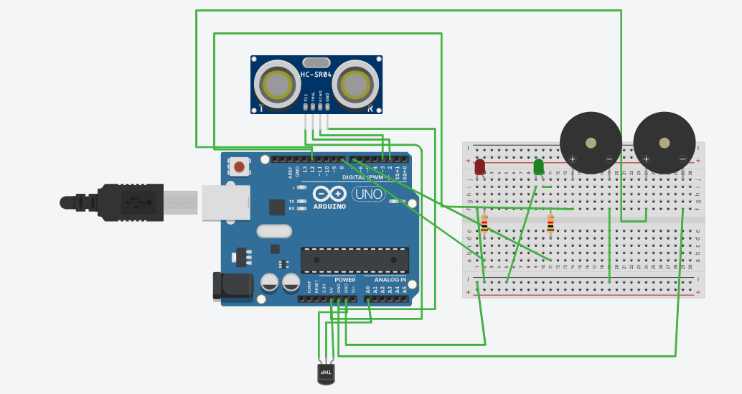

**SCHEMATIC VIEW:**

